功能：
exptTaxiBJ.py代码实现

环境：
Docker+cmd开发模式
sunfengzhen@gpu:~$ docker exec -it f66db6d10957 /bin/bash
root@f66db6d10957:/home/sunfengzhen/feng# vim ~/.keras/keras.json
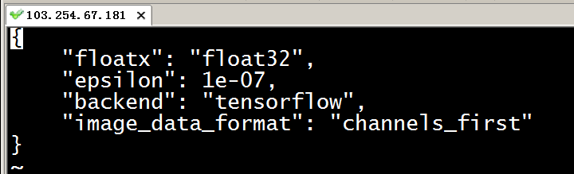

代码：
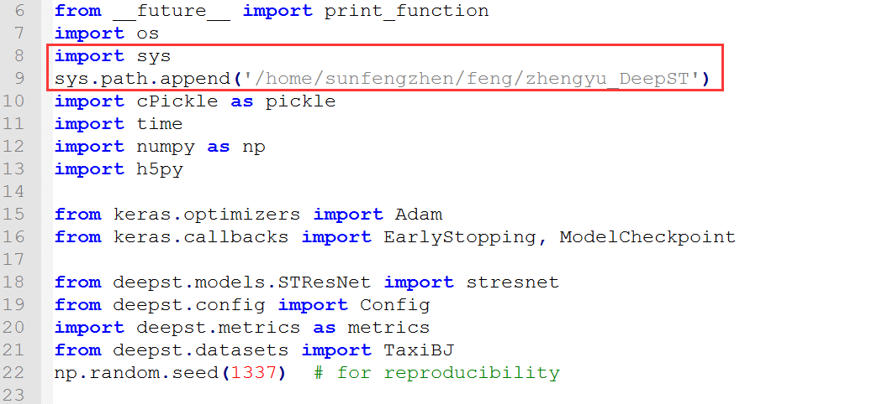
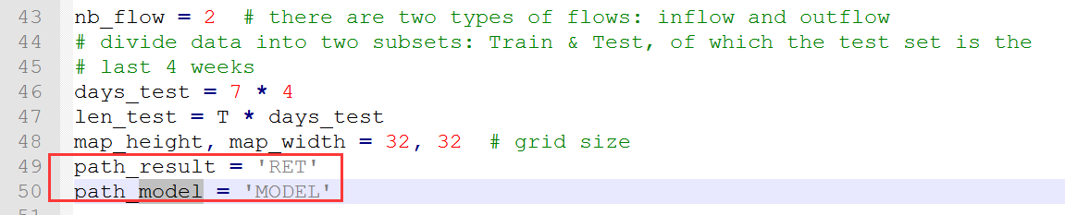
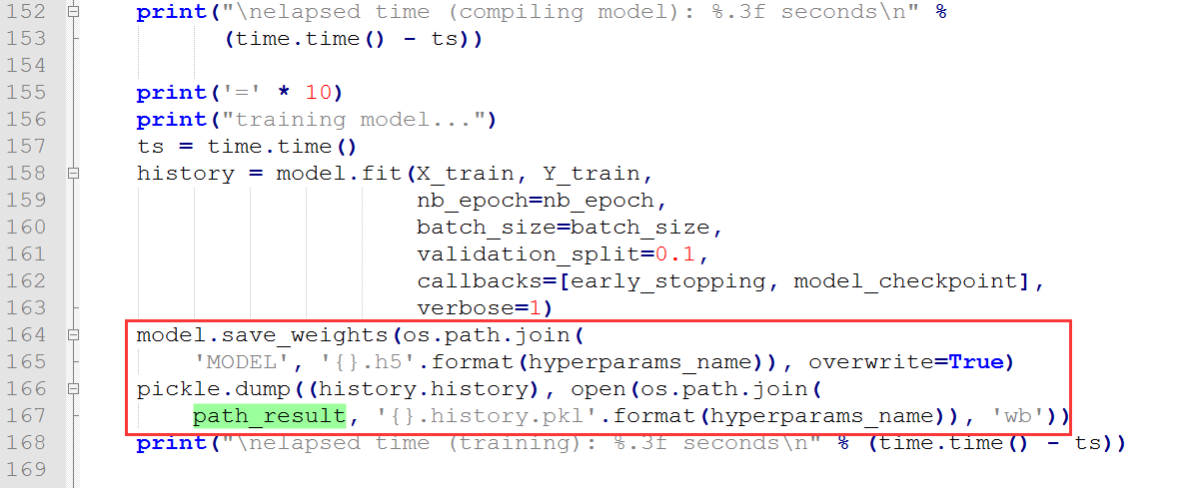
运行：
root@f66db6d10957:/home/sunfengzhen/feng/zhengyu_DeepST/scripts/papers/AAAI17/TaxiBJ# nohup python2 exptTaxiBJ.py 10 >out.log &

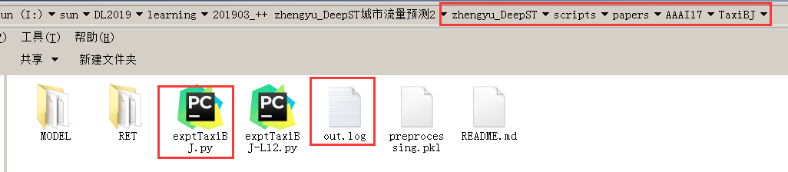

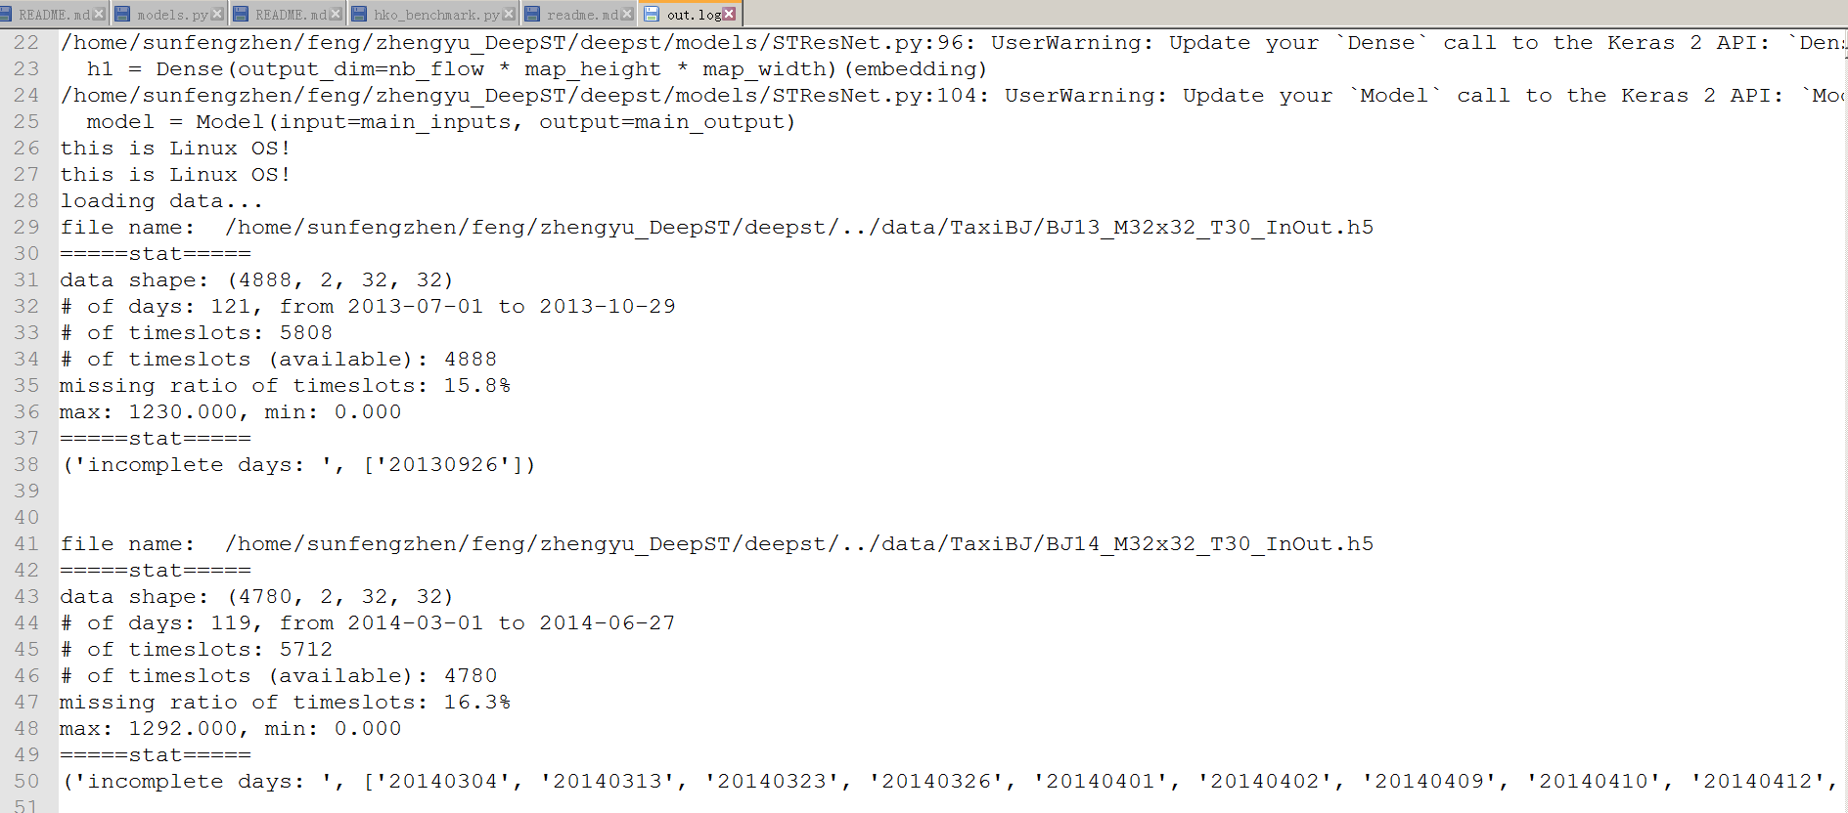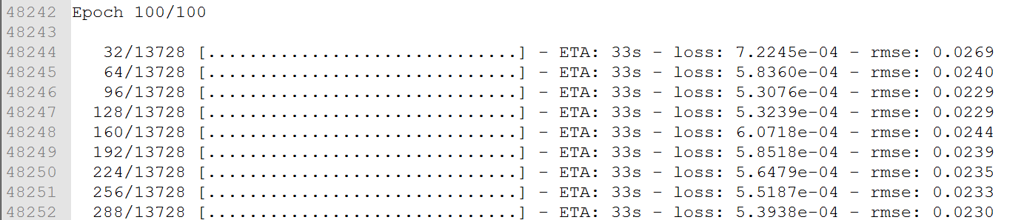
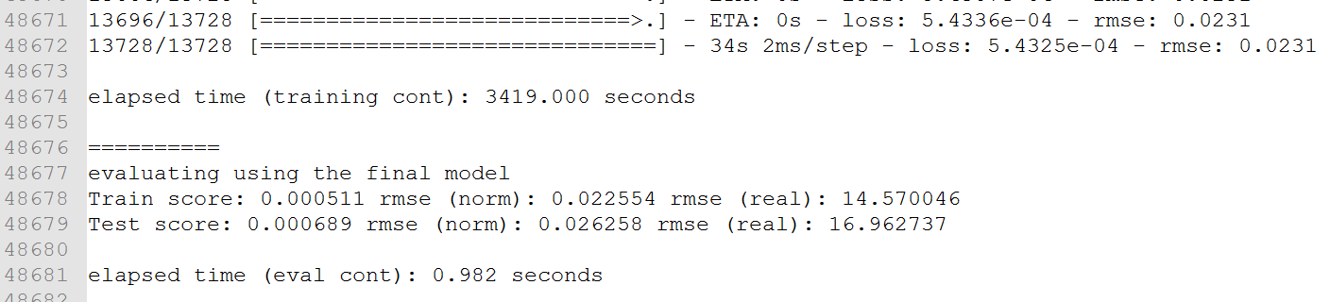

Docker+pycharm开发模式
sunfengzhen@gpu:~$ docker exec -it 48e30d8775ae /bin/bash
Usage:
THEANO_FLAGS="device=gpu0" python exptTaxiBJ.py [number_of_residual_units]
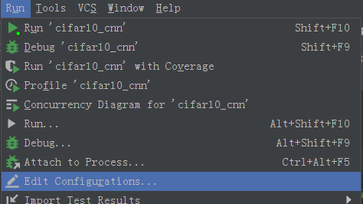
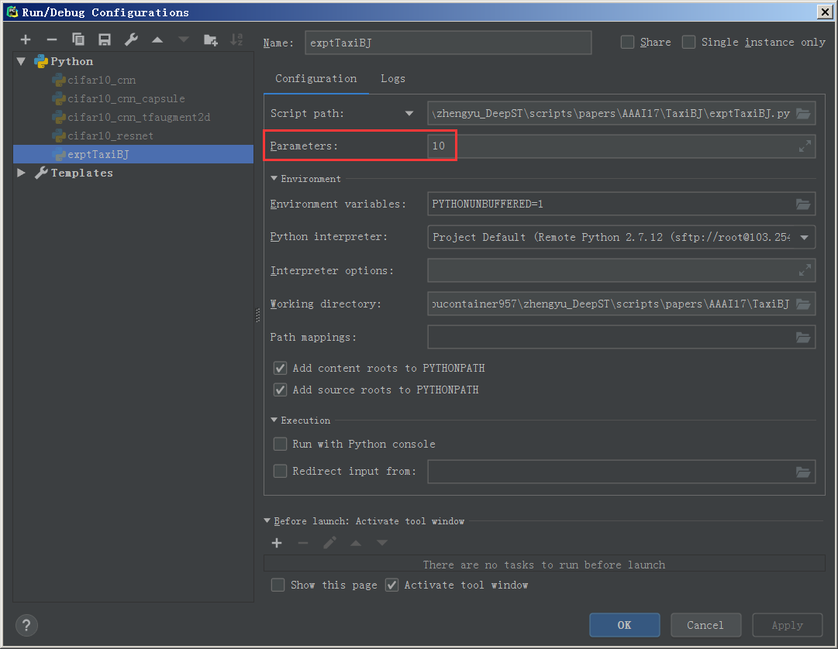
参考：https://blog.csdn.net/googler_offer/article/details/79039039

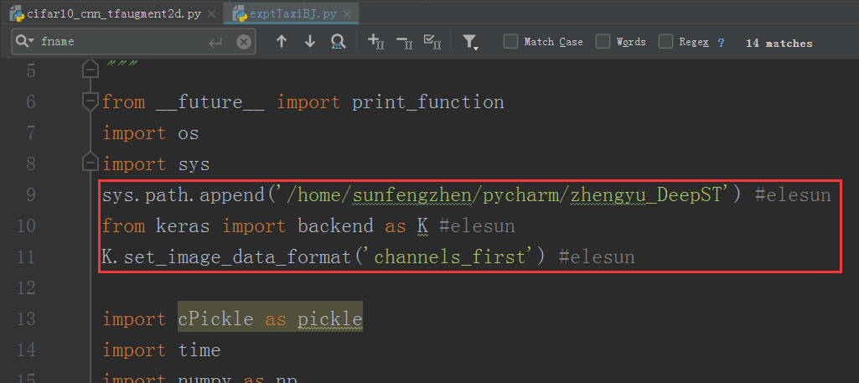
使用Pycharm给Python程序传递参数
https://blog.csdn.net/counte_rking/article/details/78837028

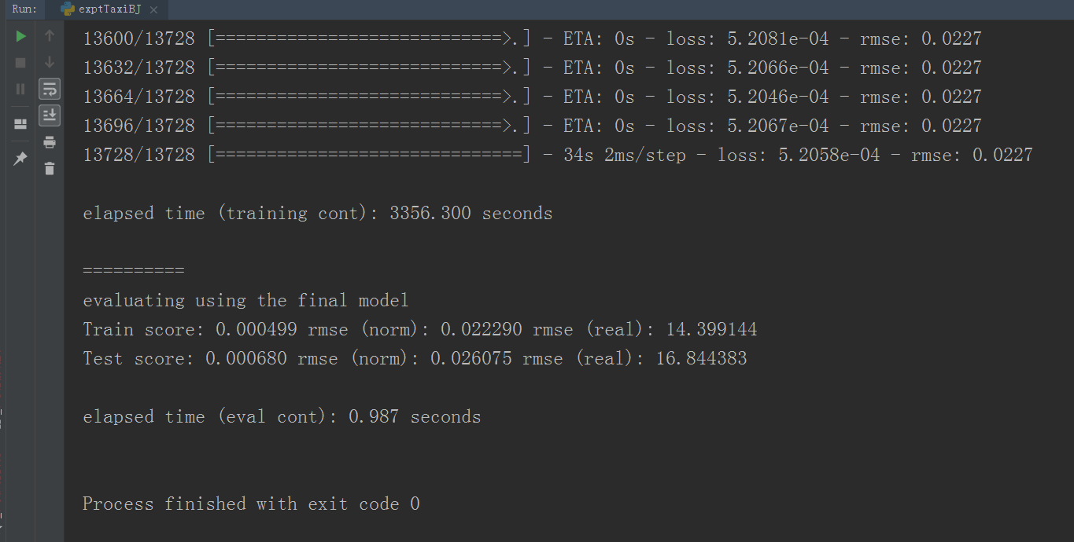

以下为以前的参考：
环境：
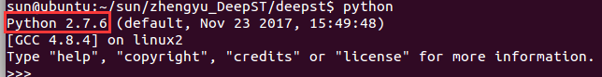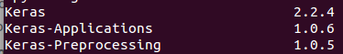
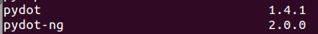

文件：
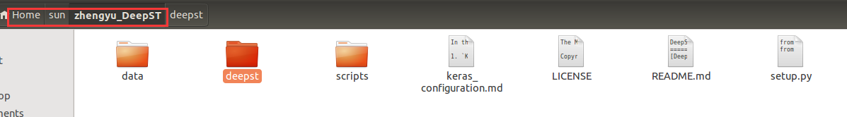


代码运行：
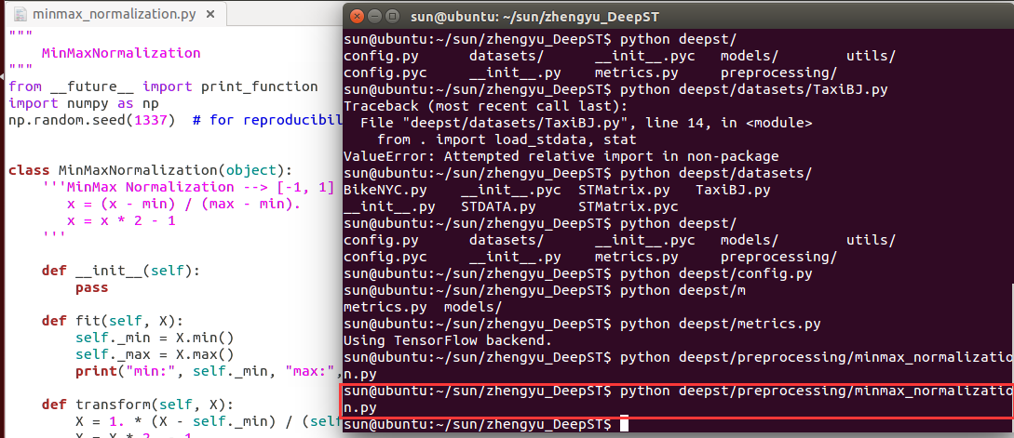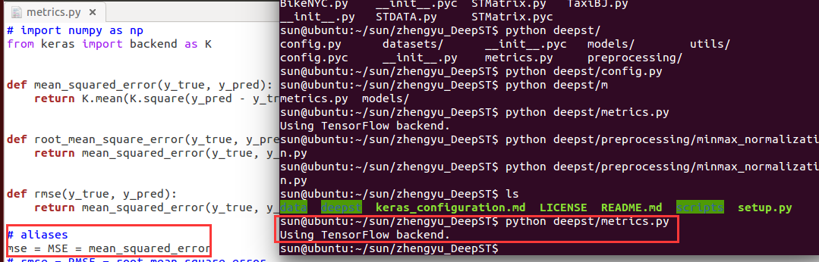

问题：
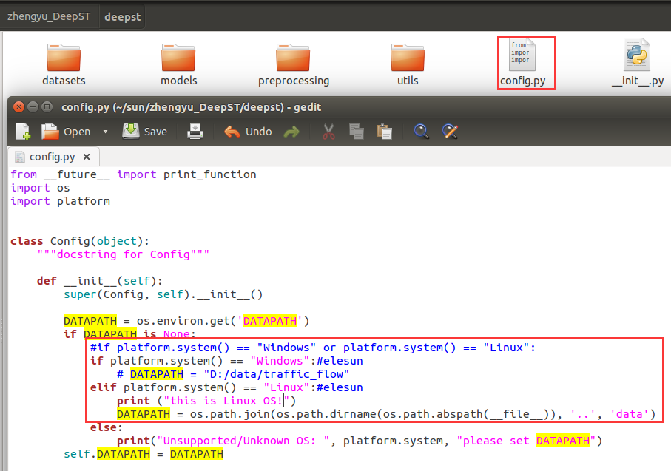

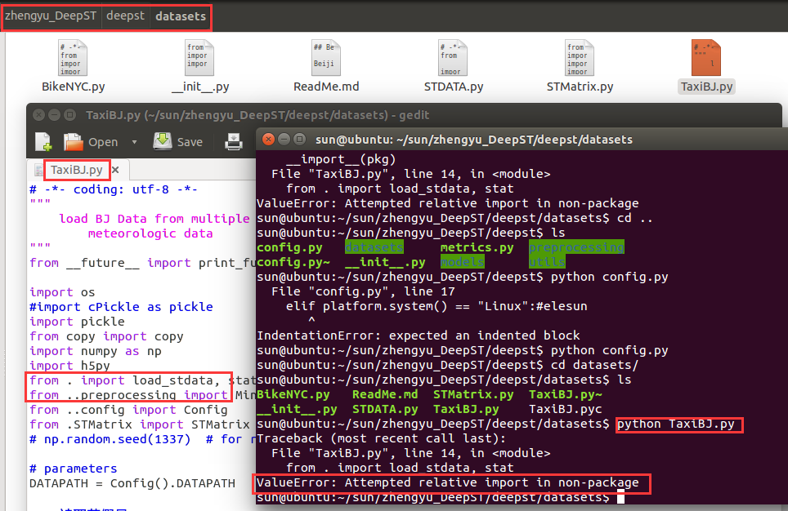
ValueError: Attempted relative import in non-package
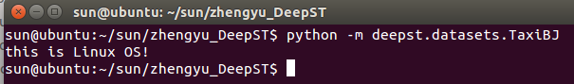

3)
sun@ubuntu:~/sun/zhengyu_DeepST$ THEANO_FLAGS=profile=True,device=cpu python ./scripts/papers/AAAI17/TaxiBJ/exptTaxiBJ-L12.py
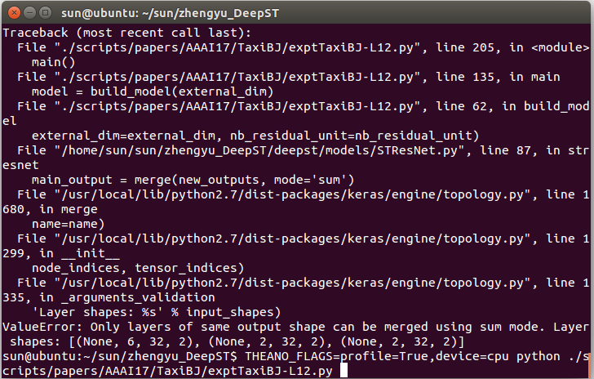
ValueError: Only layers of same output shape can be merged using sum mode. Layer shapes: [(None, 6, 32, 2), (None, 2, 32, 2), (None, 2, 32, 2)]

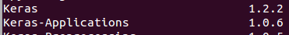
Sudo pip install keras==2.2.4
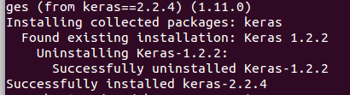
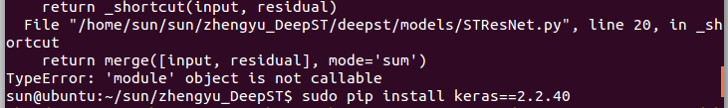
不是版本问题，改回去
sun@ubuntu:~/sun/zhengyu_DeepST$ sudo pip install keras==1.2.2
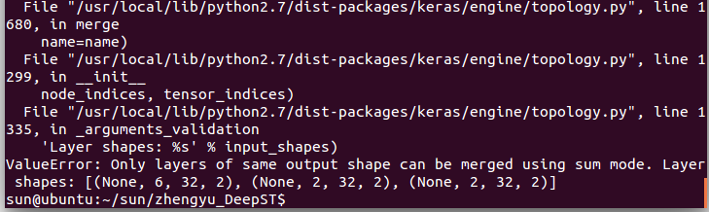
https://github.com/lucktroy/DeepST/issues/19
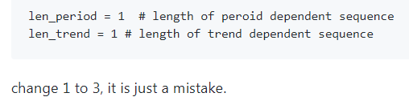
len_period = 3#1 elesun # length of peroid dependent sequence

len_trend = 3#1 elesun # length of trend dependent sequence
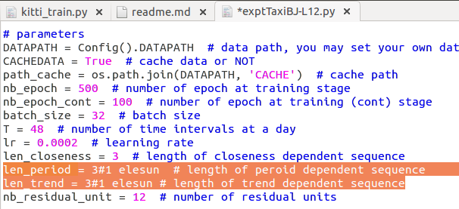

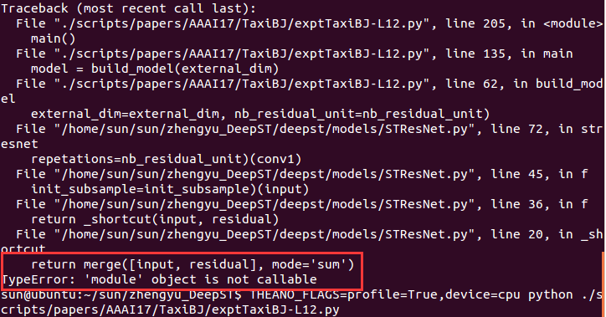
Keras2.0已取消merge，直接进行sum add
返回keras1.0版本
sun@ubuntu:~/sun/zhengyu_DeepST$ sudo pip install keras==1.2.2
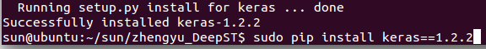
sun@ubuntu:~/sun/zhengyu_DeepST$ THEANO_FLAGS=profile=True,device=cpu python ./scripts/papers/AAAI17/TaxiBJ/exptTaxiBJ-L12.py
ValueError: Error when checking model target: expected activation_76 to have shape (None, 6, 32, 2) but got array with shape (6528, 2, 32, 32)

$ gedit ~/.keras/keras.json

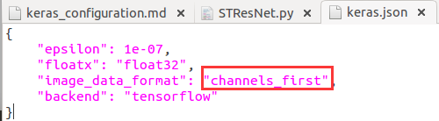
返回keras2.0版本
sun@ubuntu:~/sun/zhengyu_DeepST$ sudo pip install keras==2.2.4
参考：https://github.com/lucktroy/DeepST/issues/6
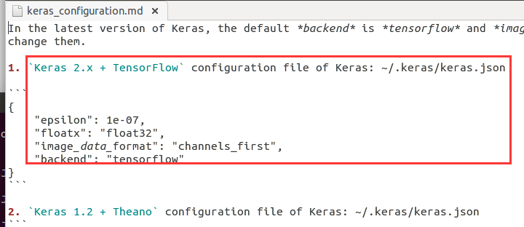
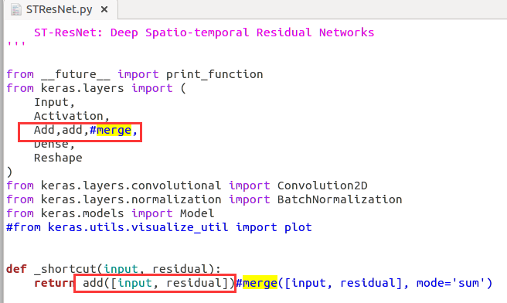
File "/home/sun/sun/zhengyu_DeepST/deepst/models/STResNet.py", line 20, in _shortcut
return Add([input, residual])#elesun merge([input, residual], mode='sum')
TypeError: __init__() takes exactly 1 argument (2 given)
解决：把Add改成小写add
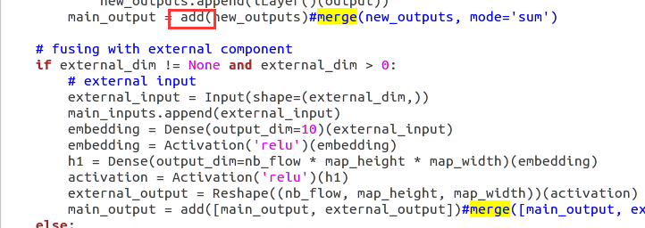

Training OK
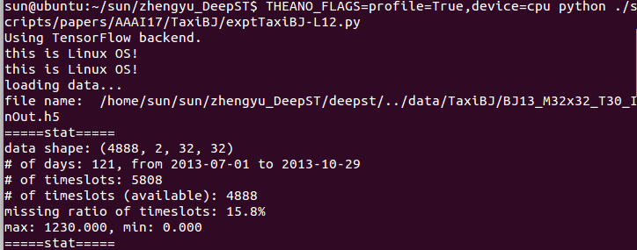
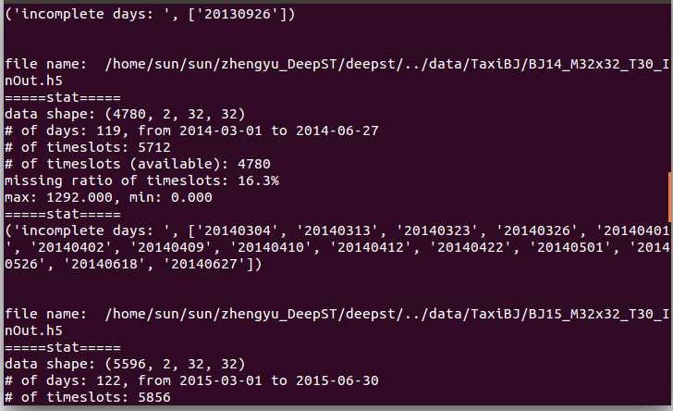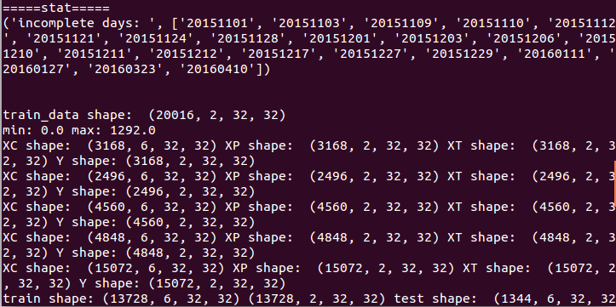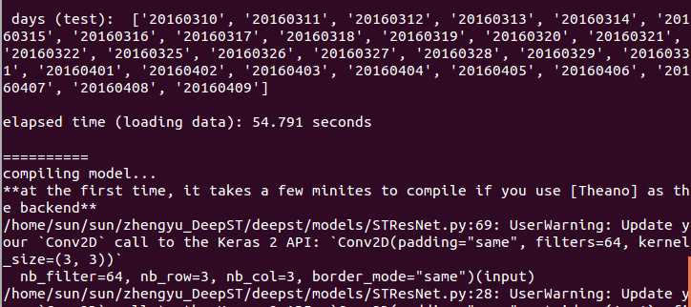

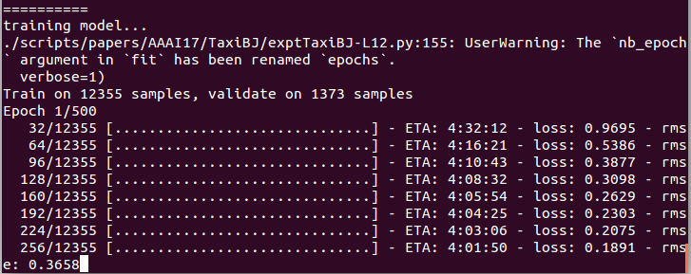

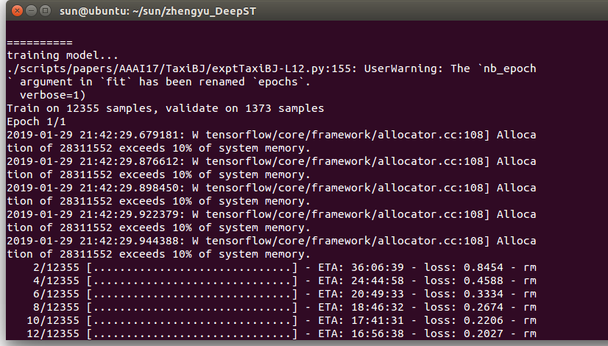
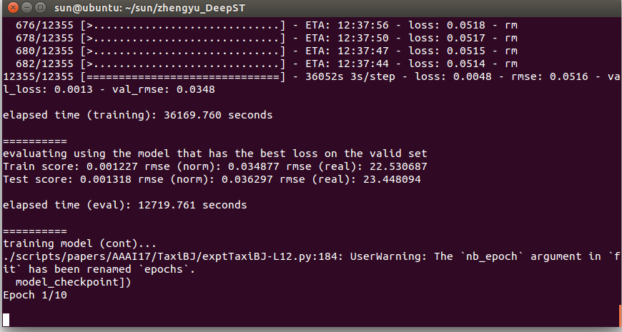

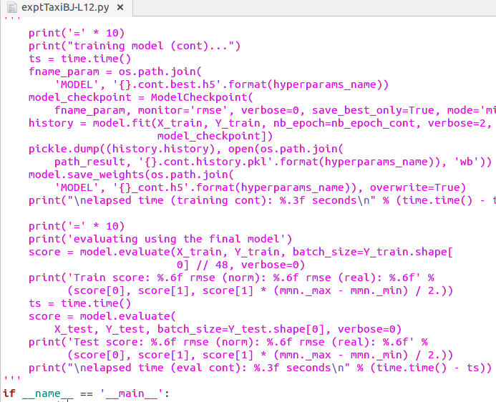
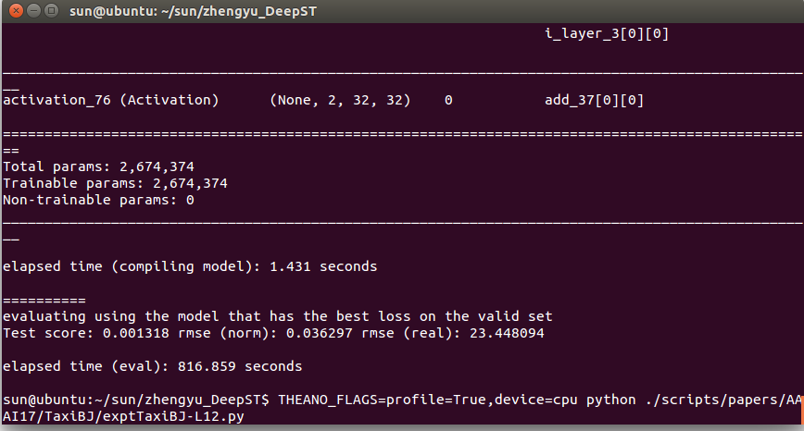

用GPU云主机实现：实现
THEANO_FLAGS=profile=True,device=cpu python ./scripts/papers/AAAI17/TaxiBJ/exptTaxiBJ-L12.py
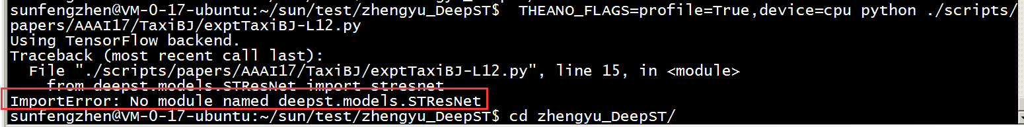

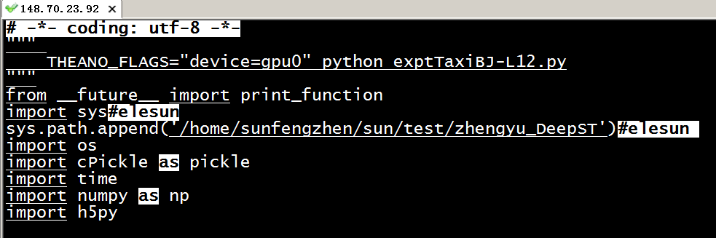
sunfengzhen@VM-0-17-ubuntu:~/sun/test/zhengyu_DeepST$ vim scripts/papers/AAAI17/TaxiBJ/exptTaxiBJ-L12.py
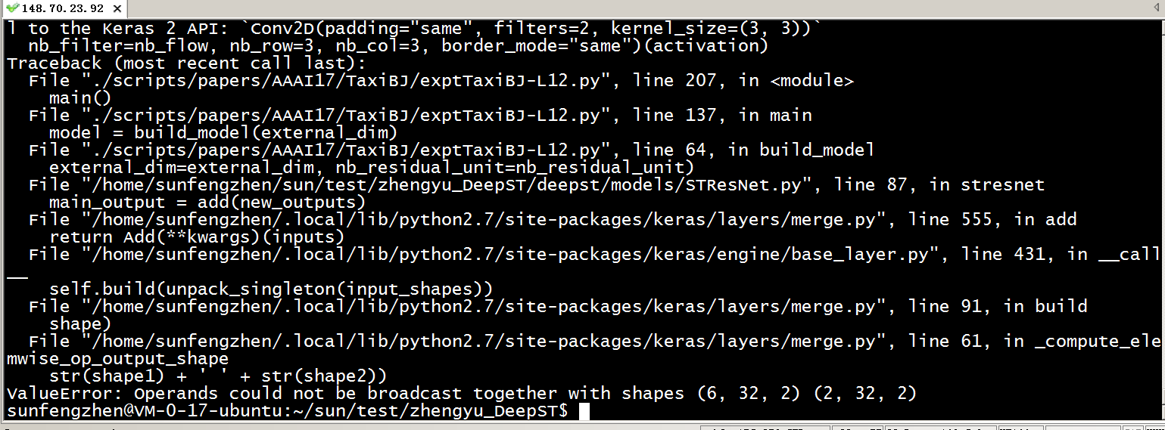
问题原因为：
OK

外网IP：103.254.67.181
账号：sunfengzhen 密码：sun
docker exec -it 容器名称 /bin/bash 注：命令最后参数 /bin/bash： 指进入容器时执行的命令
docker exec -it f66db6d10957 /bin/bash

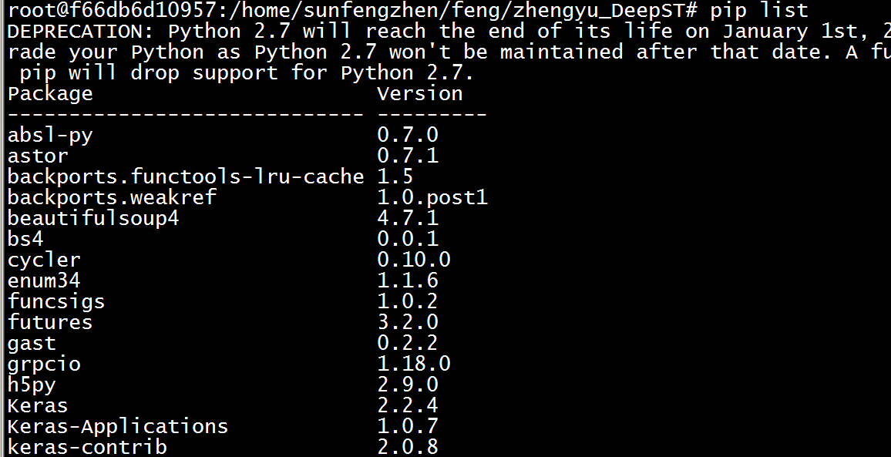
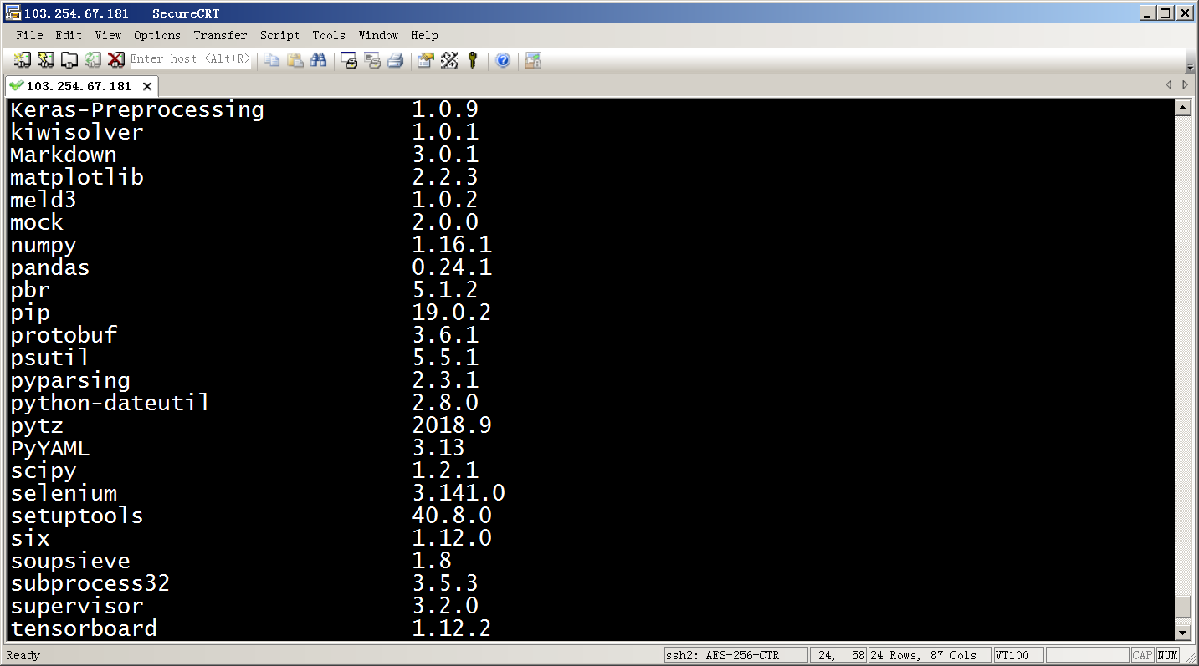
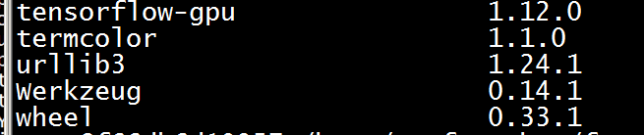
# THEANO_FLAGS=profile=True,device=cpu python2 ./scripts/papers/AAAI17/TaxiBJ/exptTaxiBJ-L12.py
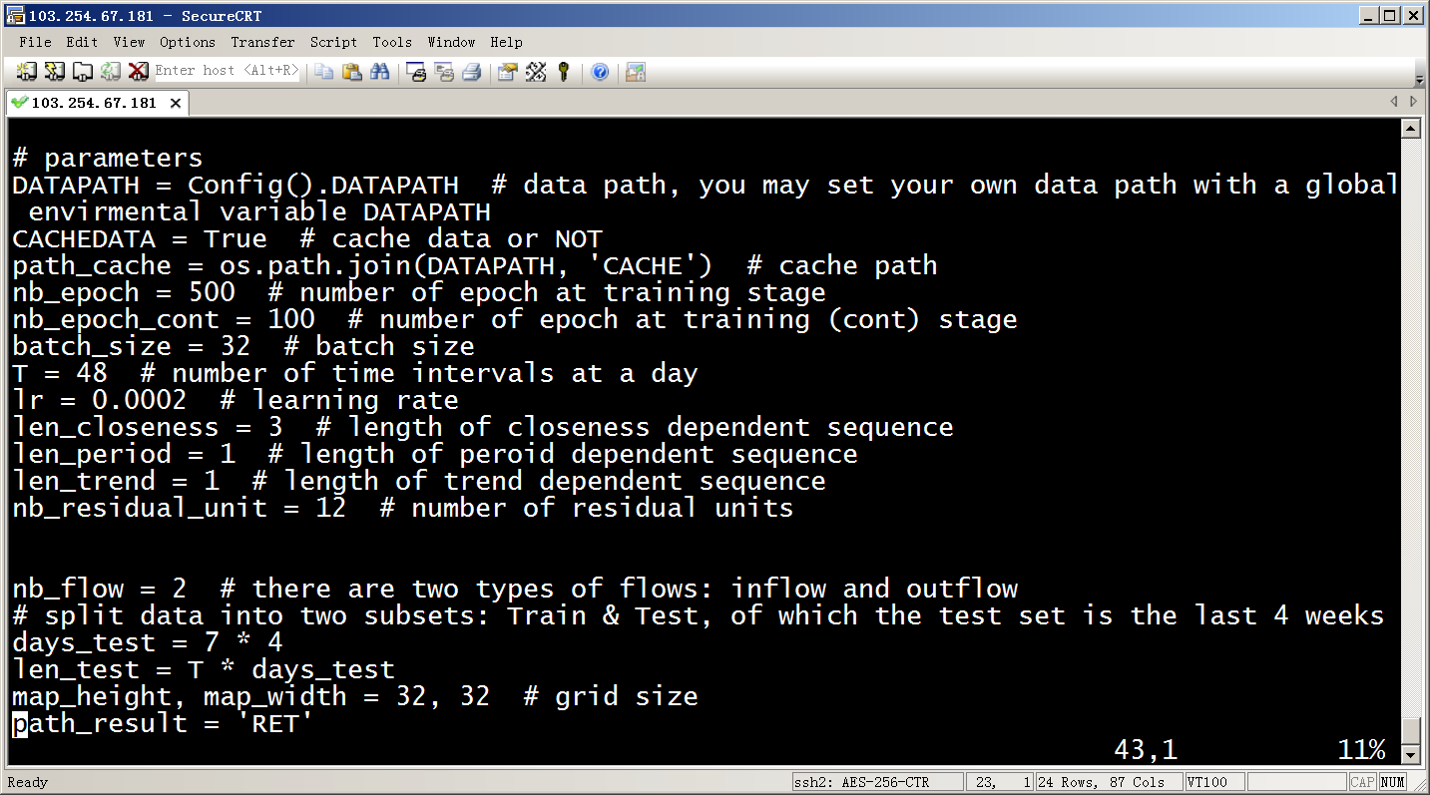
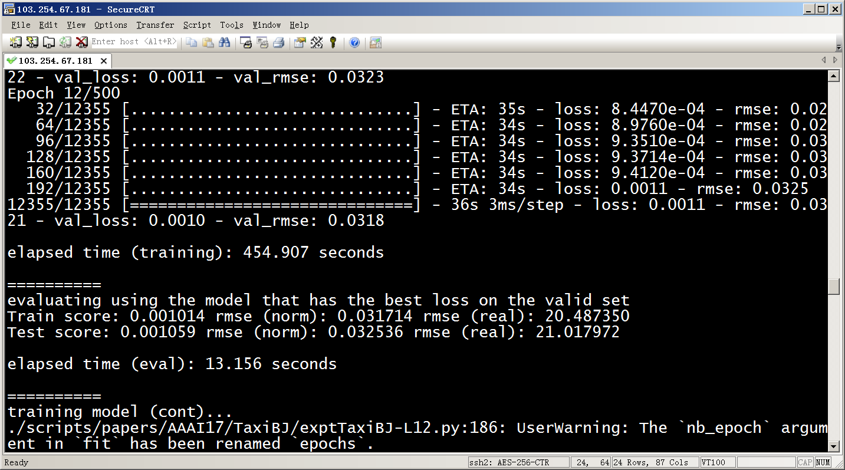
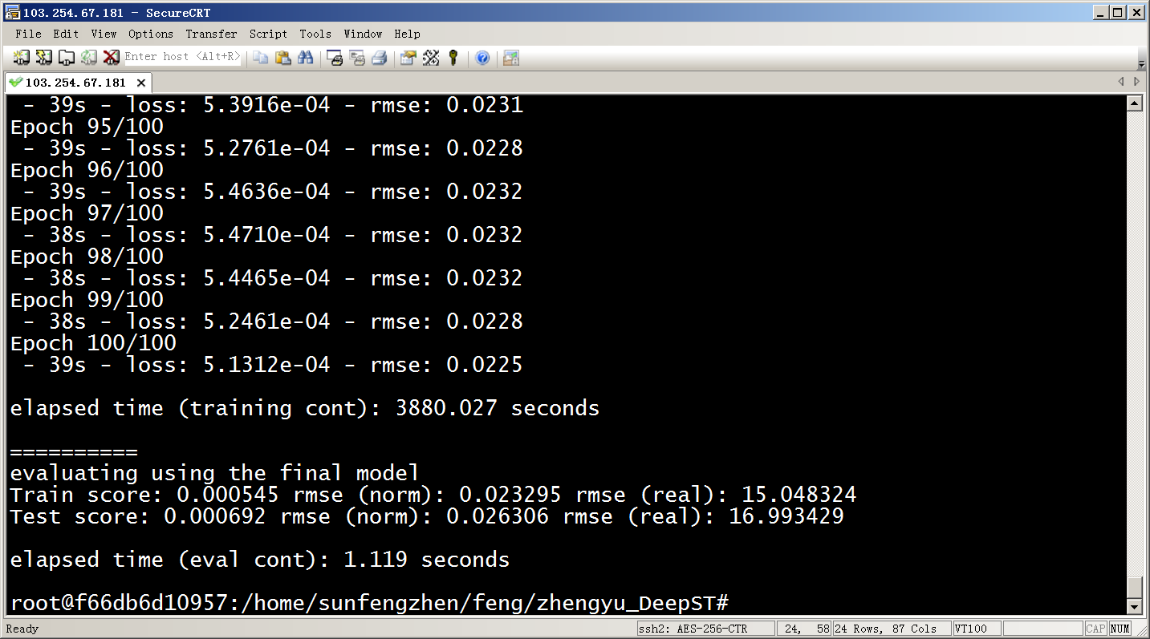

其他问题：
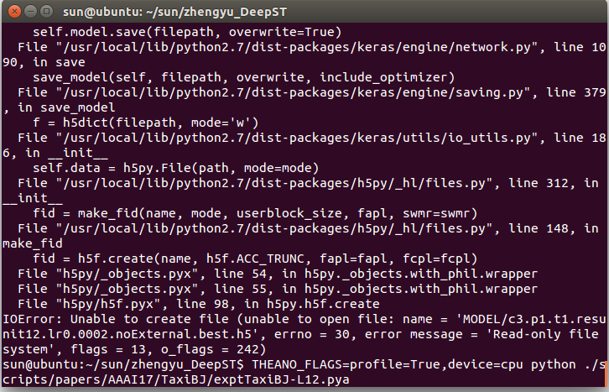
File "h5py/h5f.pyx", line 98, in h5py.h5f.create
IOError: Unable to create file (unable to open file: name = 'MODEL/c3.p1.t1.resunit12.lr0.0002.noExternal.best.h5', errno = 30, error message = 'Read-only file system', flags = 13, o_flags = 242)

参考：
https://github.com/lucktroy/DeepST

